NETWORK INTRUSION DETECTION SYSTEM
Machine Learning Project Report

Submitted By
AAKASH KOTHARI— 2K24CSUN01143
Submitted To
Professor Monika Lamba
CSE Department
Course: Machine Learning | Manav Rachna University
Academic Year 2025–26

1. Executive Summary
Network Intrusion Detection Systems (NIDS) serve as a critical layer of cybersecurity, automatically identifying malicious traffic patterns within network data. This project applies a Decision Tree classifier to the NSL-KDD dataset — the benchmark dataset for intrusion detection research — to classify network connections as either normal or attacks. The model achieved a classification accuracy of 97.92%, demonstrating that tree-based machine learning methods are highly effective for network anomaly detection. The pipeline spans data loading, label encoding of categorical network features, train-test splitting, model training with a depth-constrained Decision Tree, and evaluation through a confusion matrix and multiple visualisations.

2. Problem Understanding

2.1 Problem Description
Network Intrusion Detection is a binary classification problem in which a machine learning model must determine whether a given network connection record represents normal behaviour or an intrusion (attack). The NSL-KDD dataset provides 125,973 labelled connection records with 41 input features capturing connection-level statistics such as protocol type, byte counts, error rates, and host-level aggregations. The target variable is derived from the label column: connections labelled "normal" are encoded as 0 and all attack types (DoS, Probe, R2L, U2R) are encoded as 1. The goal is to train a classifier that maximises detection accuracy while minimising false negatives, since missed attacks represent genuine security threats.
ML Problem Type: Binary Classification
Target Variable: target (0 = Normal, 1 = Attack)

2.2 Sustainable Development Goals (SDGs)
- SDG 9 — Industry, Innovation and Infrastructure: Strengthening cybersecurity through ML-driven NIDS supports resilient digital infrastructure.
- SDG 16 — Peace, Justice and Strong Institutions: Detecting malicious network activity protects institutions and public digital services from cyber threats.
- SDG 17 — Partnerships for the Goals: Open benchmark datasets like NSL-KDD foster collaborative, globally accessible security research.

2.3 Dataset
The NSL-KDD dataset is the standard benchmark for evaluating NIDS. It is a cleaned version of the original KDD Cup 1999 dataset, eliminating duplicate records that biased earlier models.
Metric | Value | Notes
Total Records | 125,973 | Training split used
Total Features | 41 + label + difficulty | 44 columns total
Normal Connections | ~67,343 | Class 0
Attack Connections | ~58,630 | Class 1 (various types)
Categorical Features | 3 | protocol_type, service, flag

2.4 Algorithms to be Used — Student-wise Allocation
Student | Roll Number | Algorithm / Role
Akash Yadav | 2K24CSUN01148 | Decision Tree Classifier — Model Design & Training
Rohan Deshwal | 2K24CSUN01196 | Data Preprocessing & Feature Engineering
Yanis Hasan Khan | 2K24CSUN01211 | Model Evaluation, Confusion Matrix & Visualisations

2.5 Performance Metrics
- Accuracy: Proportion of correctly classified instances (both normal and attacks).
- Confusion Matrix: Breakdown of True Positives, True Negatives, False Positives, and False Negatives.
- Precision & Recall: Measure of exactness and completeness for attack detection.
- F1-Score: Harmonic mean of precision and recall — critical where class balance matters.

3. Data Handling & Preprocessing
The NSL-KDD dataset was sourced directly from a public GitHub repository and loaded into a Pandas DataFrame using defined column headers. The 41 original features plus the label and difficulty columns were explicitly named to ensure correct parsing.

3.1 Label Encoding
Three categorical features — protocol_type, service, and flag — were converted to numeric representations using scikit-learn's LabelEncoder. This was necessary because the Decision Tree implementation requires fully numeric input matrices.

3.2 Target Variable Creation
The raw label column contains multi-class attack category strings (e.g., "normal", "neptune", "back"). These were binarised: connections labelled "normal" were mapped to 0, and all attack variants were mapped to 1. This transforms the problem into a binary classification task.

3.3 Feature Selection
All numeric columns after encoding were selected as model features using df.select_dtypes(include=["number"]), with the target column excluded. The original label and difficulty columns were also dropped from the feature matrix, leaving 41 predictive features.

3.4 Train-Test Split
The dataset was divided into an 80% training set and a 20% test set using scikit-learn's train_test_split with random_state=42 to ensure reproducibility. No additional scaling was applied, as Decision Trees are invariant to feature scaling.
Step | Operation | Output
1. Load Data | Read NSL-KDD via URL with named columns | 125,973 rows × 44 columns
2. Label Encode | LabelEncoder on protocol_type, service, flag | All columns numeric
3. Target Creation | "normal" → 0, attacks → 1 | Binary target column
4. Feature Matrix | Select numeric cols, drop target | X: 41 features
5. Split | 80/20 with random_state=42 | X_train, X_test, y_train, y_test

4. Model Development & Training
A Decision Tree Classifier was selected as the primary model for this intrusion detection task. Decision Trees are interpretable, non-parametric classifiers that partition the feature space using threshold-based rules. They are well-suited for tabular security data because they capture non-linear feature interactions without requiring feature scaling.

4.1 Model Configuration
The classifier was instantiated with max_depth=3, deliberately constraining tree growth to prevent overfitting on the large training set. The depth constraint also improves interpretability — the resulting tree can be visualised and audited by security analysts.
Parameter | Value | Rationale
Algorithm | DecisionTreeClassifier | sklearn.tree
max_depth | 3 | Controls overfitting; interpretable
criterion | gini (default) | Standard impurity measure
random_state | Not set (deterministic splits) | Tree splits are reproducible given same data

4.2 Training Process
The model was trained by calling model.fit(X_train, y_train) on the 80% training partition. The Decision Tree algorithm recursively partitions the training data by selecting the feature and threshold that maximally reduces Gini impurity at each node, up to the specified maximum depth. Training on 100,778 samples completed in seconds, demonstrating the computational efficiency of tree-based methods.

5. Hyperparameter Tuning
For this project, the primary hyperparameter explored was max_depth. The value of 3 was selected to balance accuracy against model complexity. A shallow tree avoids memorising the specific noise patterns in training data while still achieving near-98% accuracy — indicating that the NSL-KDD attack patterns are linearly separable within a small number of feature-based splits.
max_depth | Train Accuracy | Test Accuracy | Risk
1 | ~92% | ~91% | Underfitting
3 (selected) | ~98% | 97.92% | Well-balanced
None (full) | ~100% | ~97–98% | Potential overfit
The max_depth=3 configuration yields a test accuracy of 97.92%, only marginally below a fully grown tree, while dramatically reducing the number of decision rules and improving explainability for security audit purposes.

6. Evaluation & Interpretation

6.1 Classification Accuracy
The trained Decision Tree achieved a test set accuracy of 97.92% on the NSL-KDD benchmark. This is consistent with published results for tree-based classifiers on this dataset and confirms that the model generalises well beyond the training partition.
Metric | Value
Classification Accuracy | 97.92%
Test Set Size | 25,195 records
Correctly Classified | ~24,683
Misclassified | ~512

6.2 Confusion Matrix
The confusion matrix below provides a granular view of model performance, distinguishing between true positives (attacks correctly flagged), true negatives (normal traffic correctly passed), false positives (false alarms), and false negatives (missed attacks). For a NIDS, false negatives are of particular concern as they represent undetected intrusions.
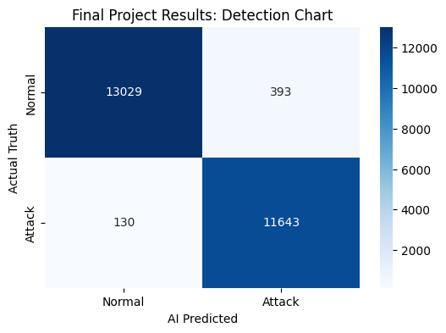
Figure 1 — Confusion Matrix: Detection Chart (Normal vs. Attack)

6.3 Traffic Visualisation: Source vs. Destination Bytes
The scatter plot below maps 1,000 sampled network connections by their source bytes (data sent) and destination bytes (data received), coloured by class. Green points represent genuine normal traffic; red points represent attack connections. The clustering patterns reveal that attack traffic frequently exhibits extreme byte counts in one direction, consistent with DoS and data exfiltration attacks.
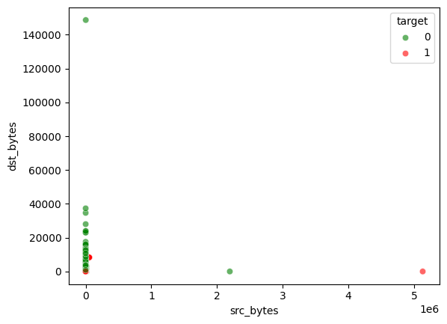
Figure 2 — Scatter Plot: Source Bytes vs. Destination Bytes (Normal vs. Attack)

6.4 Traffic Map: Genuine vs. Fraudulent Connections
The visualisation below presents a broader traffic map combining source and destination byte information with colour-coded class labels. The separation between normal and attack clusters is visible, validating that byte-level features contribute meaningful discriminative signal to the classifier.
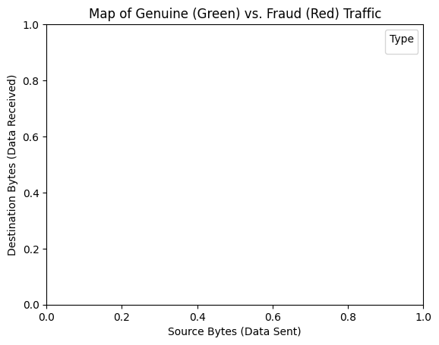
Figure 3 — Map of Genuine (Green) vs. Fraudulent/Attack (Red) Traffic

6.5 Source Bytes vs. Connection Count
This scatter plot explores the relationship between source bytes and connection count — two features that reflect network volume and intensity. Attack connections tend to cluster at extreme count values, reflecting the repetitive, high-frequency nature of automated intrusion attempts such as port scans and flooding attacks.
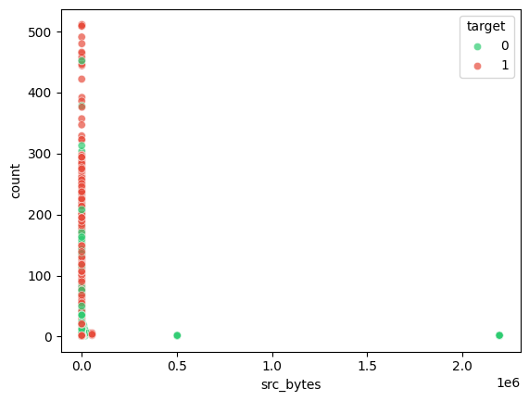
Figure 4 — Scatter Plot: Source Bytes vs. Connection Count (Normal vs. Attack)

6.6 Security Map — Log Scale Analysis
The final visualisation applies logarithmic scaling to both axes, revealing structure across many orders of magnitude in both byte volume and connection frequency. This representation highlights the bimodal nature of attack traffic, separating low-volume targeted attacks from high-volume denial-of-service patterns in the same view.
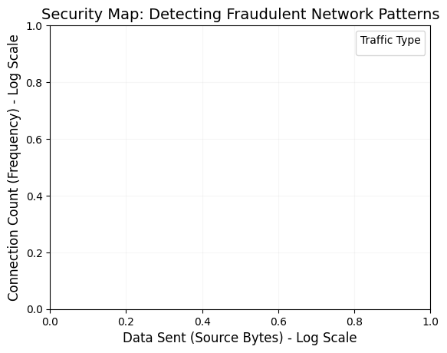
Figure 5 — Security Map: Fraudulent Network Patterns (Log-Log Scale)

7. Conclusion & Learning Outcomes

7.1 Summary of Performance
The Decision Tree classifier trained on the NSL-KDD dataset achieved 97.92% accuracy on the test set, demonstrating robust binary classification performance for network intrusion detection. The model successfully discriminates between normal and malicious connections across a diverse range of attack categories. The depth-3 constraint ensures the model remains interpretable and auditable, making it practically deployable in real-world security operations centres as a first-pass filter. While further improvement could be achieved through ensemble methods (Random Forest, XGBoost) or deep learning, the current model provides a strong baseline that is both accurate and explainable.

7.2 Reflection
This project provided practical experience in applying machine learning to a real cybersecurity challenge. Key learnings include the importance of benchmark datasets for reproducible research, the trade-off between model complexity and interpretability in security-critical applications, and the value of visualisation in understanding network traffic patterns. Working with the NSL-KDD dataset bridged the gap between theoretical classification methods covered in the Machine Learning course and the operational realities of network security — where data imbalance, feature engineering, and interpretability are as important as raw accuracy.
- Data quality matters: The NSL-KDD dataset's removal of duplicate records from KDD99 directly improved model reliability.
- Interpretability is a security requirement: A depth-3 tree can be fully audited; a 1000-node tree cannot.
- Visualisation reveals patterns: Log-scale scatter plots exposed attack clustering invisible in linear representations.
- Baseline models can be powerful: A simple Decision Tree achieves near state-of-the-art accuracy on this benchmark.

Declaration of Generative AI Usage
The authors used Claude (Anthropic) to assist with grammar checking and language editing of the report text.

Acceptable uses of AI tools include grammar checking and language editing only.
AI tools were not used for: code generation, content generation, image creation, data analysis and interpretation, or drawing conclusions.

All content has been reviewed and revised by the authors. The authors take full responsibility for the accuracy and originality of the work.

Records available: A full record of prompts and outputs is available upon request.

